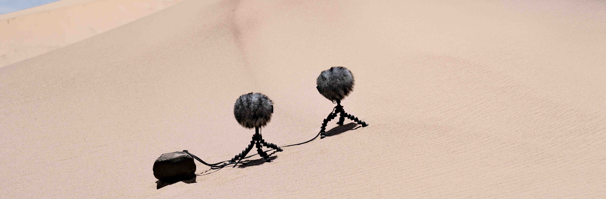Sennheiser previews MKH 8030 figure-of-eight RF condenser microphone
“It’s the missing link in the sound designer’s tool box”

Wedemark/Amsterdam, 15 September 2023 – At IBC, Sennheiser will preview the MKH 8030 RF condenser microphone with figure-of-eight pick-up pattern. The MKH 8030 will not only unlock M-S, double M-S, and Blumlein stereo recording options, but will also be a great choice wherever the highest attenuation of neighbouring sound sources is required – be it a PA system whose sound needs to be eliminated or an adjacent instrument that must not be picked up. The sound signature of the MKH 8030 has been carefully engineered to blend in harmoniously with the sound of the existing MKH 8000 series microphones.

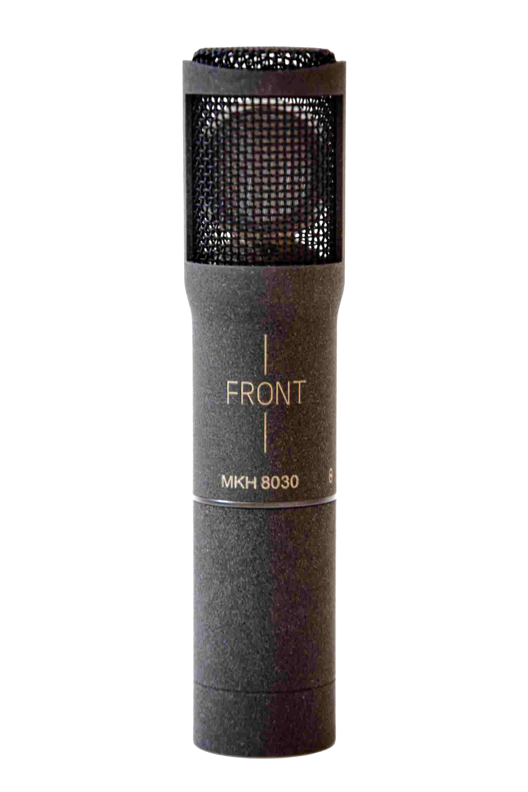 | The MKH 8030 figure-of-eight RF condenser microphone is extremely compact with a diameter of 19/21 mm and a length of 93 mm including the XLR module (preview photo only)

“We are thrilled to be previewing the MKH 8030, a microphone that the MKH user community has been expecting for quite a few years,” shares Kai Lange, Product Manager Professional, Wire-bound. “The extremely compact 8030 is ideal for field recording, sports and general broadcasting, theatres, orchestra recordings and studio music. During the past few months, field tests were successfully carried out, and we are now using the remaining months until the 8030 becomes available in Q2/2024 to implement some of the suggestions our field testers made.”

A mic series with almost proverbial robustness
Naturally, the MKH 8030 shares the qualities of the MKH 8000 family and its RF condenser principle with the unique push-pull transducer. These include high resistance to moisture, a fully floating, balanced output signal, extended low and high frequency response (30 to 50,000 Hz) and extremely low inherent self-noise. These features will enable sound recordists and engineers to capture a sound event in its entirety and with all its intricate detail, with wide dynamics, extremely low distortion, and a frequency-independent polar pattern to avoid colouration. “The MKH 8000 family are tools for creating natural sound of the highest quality and detail,” adds Lange.

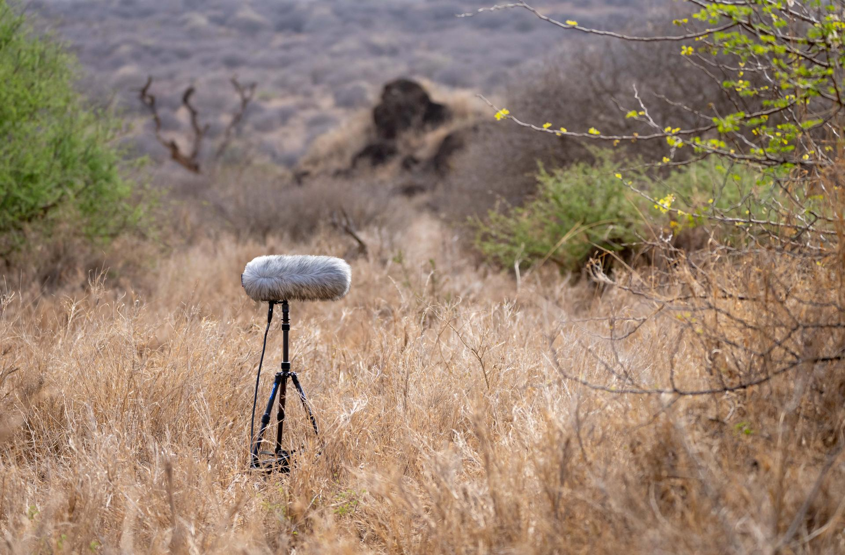 | The MKH 8000 series mics are firm favourites with field recordists  (both application pictures courtesy of George Vlad)

Outlook
Previewed at IBC, the MKH 8030 will become available during Q2 of 2024. Pre-orders will be accepted from the start of the show. Pricing: EUR 1,499 (MSRP) / USD 1,499 (MAP). Delivery will include an MZW 8030 foam windshield, an MZQ 8000 mic clamp and two Rycote back-to-back clips to create mic pairs.

At IBC 2023, the MKH 8030 can be seen with a special basket windshield and clamp – ready for MS stereo recordings.

The MKH 8030 will join the MKH 8020 (omni-directional), MKH 8090 (wide cardioid), MKH 8040 (cardioid), MKH 8050 (super-cardioid), MKH 8060 (short shotgun, super-cardioid/lobar) and MKH 8070 (long shotgun, lobar) RF condenser microphones. Also part of the family is the MKH 800 TWIN, a dual-capsule microphone whose pick-up pattern can be seamlessly adjusted at the mixing desk during recording, or even after the actual recording during post-production.

MKH 8030 Technical Data
Microphone principle: RF condenser
Pick-up pattern: figure-of-eight
Frequency response: 30 - 50,000 Hz
Equivalent noise level: 13 dB(A)
Maximum SPL: 139 dB
Dimensions: Ø 19 mm/21 mm, length: 59 mm (93 mm with XLR module)
Weight: approx. 86 g with XLR module

(Ends)

The images accompanying this media release can be downloaded here.

About the Sennheiser brand
We live and breathe audio. We are driven by the passion to create audio solutions that make a difference. Building the future of audio and bringing remarkable sound experiences to our customers – this is what the Sennheiser brand has represented for more than 75 years. While professional audio solutions such as microphones, meeting solutions, streaming technologies and monitoring systems are part of the business of Sennheiser electronic GmbH & Co. KG, the business with consumer devices such as headphones, soundbars and speech-enhanced hearables is operated by Sonova Holding AG under the license of Sennheiser.

www.sennheiser.com
www.sennheiser-hearing.com

Global Pro Audio Press Contact
Stephanie Schmidt
stephanie.schmidt@sennheiser.com
+49 (5130) 600 – 1275

